PYTHON CAPSTONE PROJECT REPORT
SOCIAL MEDIA ENGAGEMENT ANALYSIS

- Line chart - Daily engagement trends

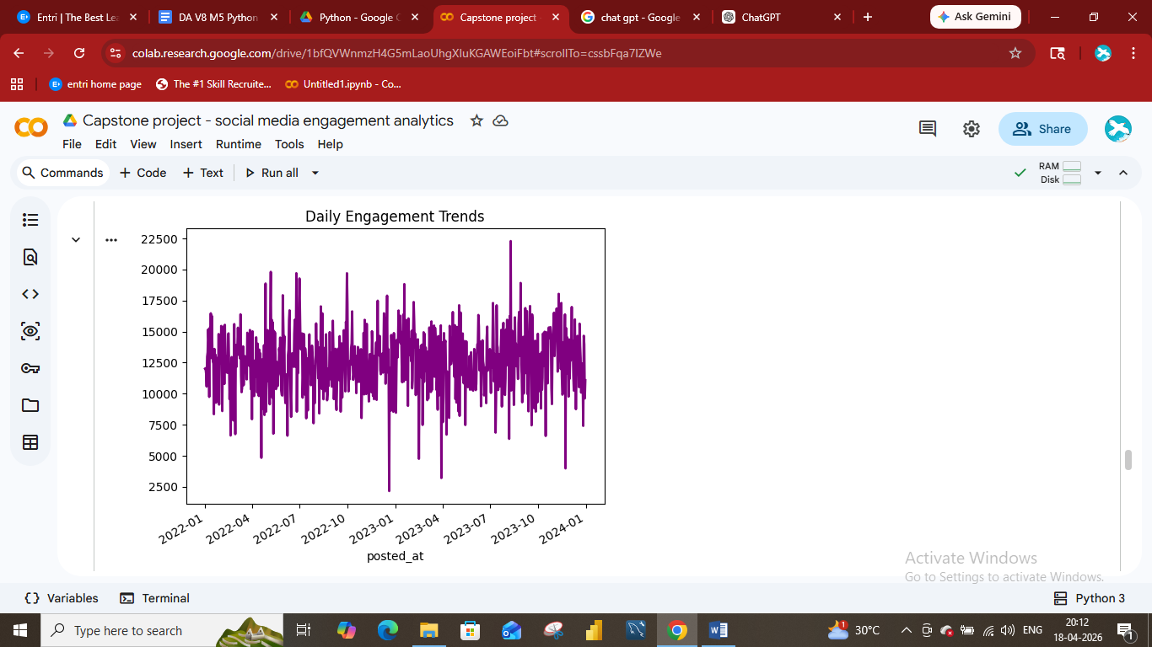
- Bar chart - Post Vs Category

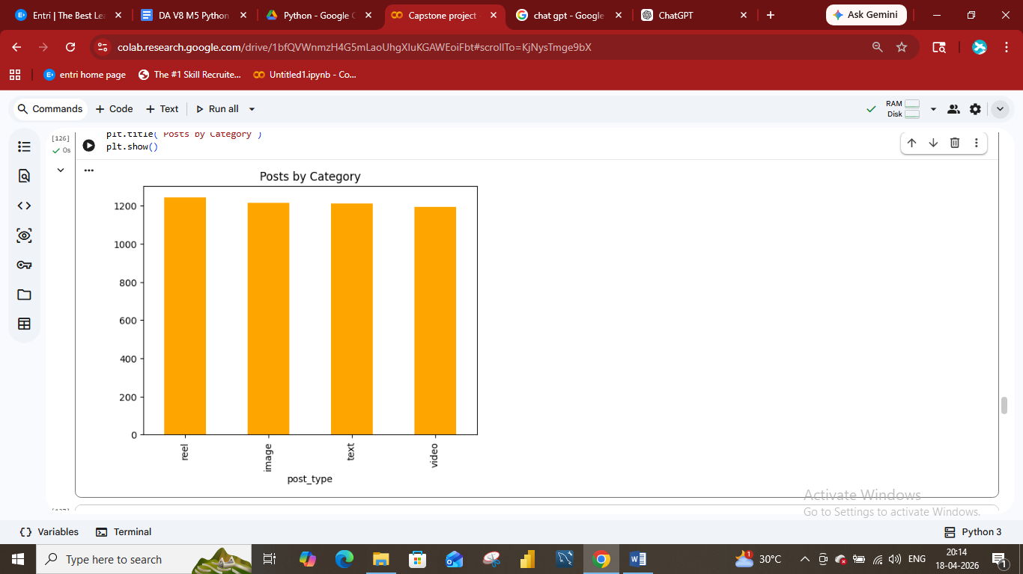

- Pie Chart - Gender distribution

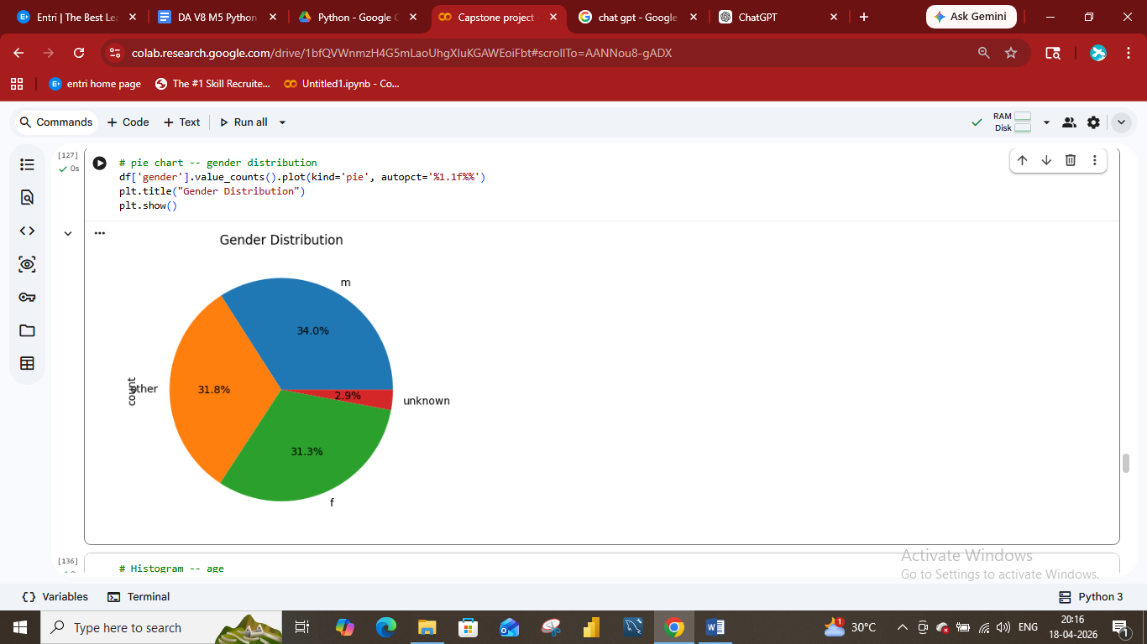

- Histogram – age Distribution

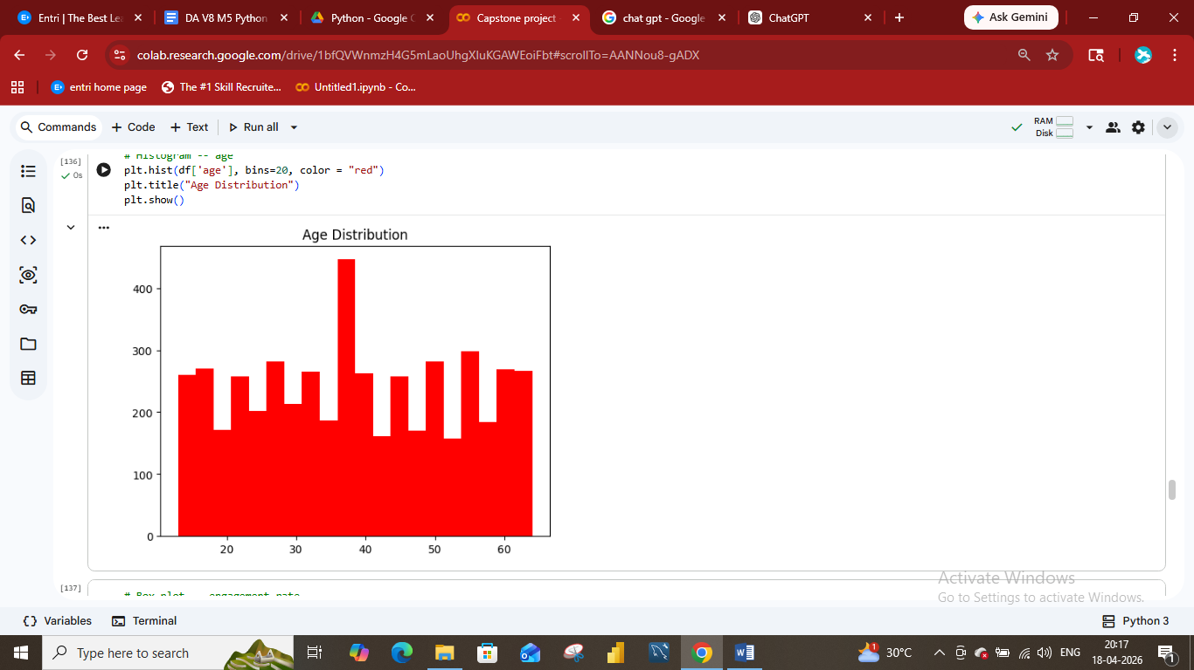

- Box plot – engagement rate

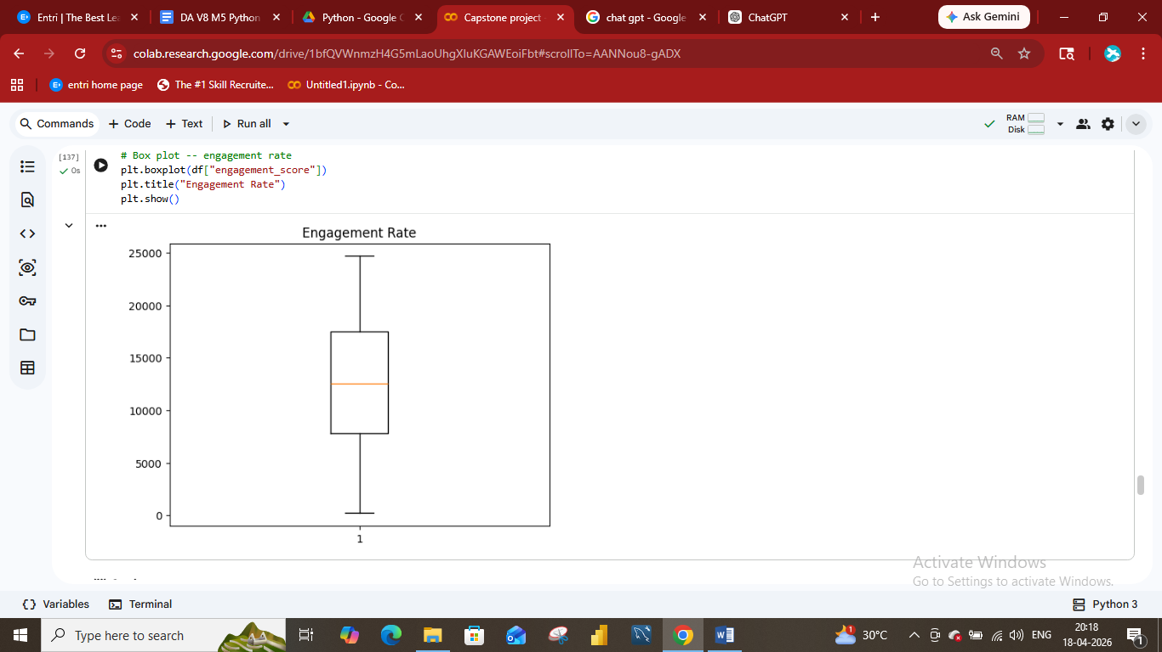

- Count plot – Total distribution of post type 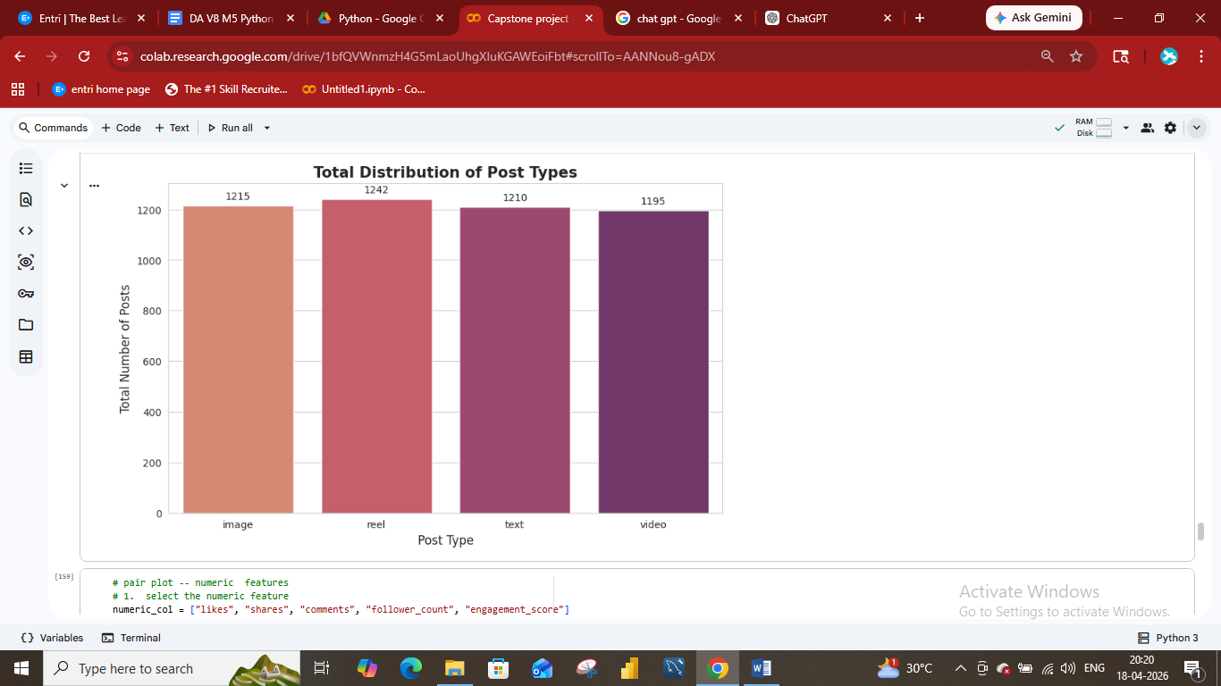

- Violin Chart - followers Vs sentiment

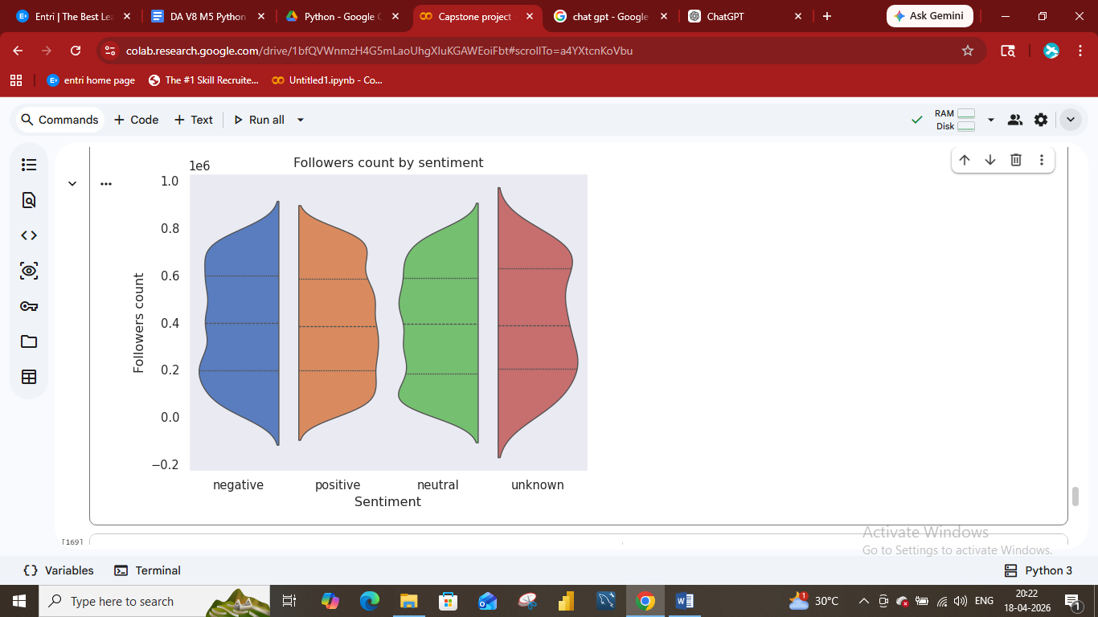

- Swarm plot – Engagement score distribution by data type

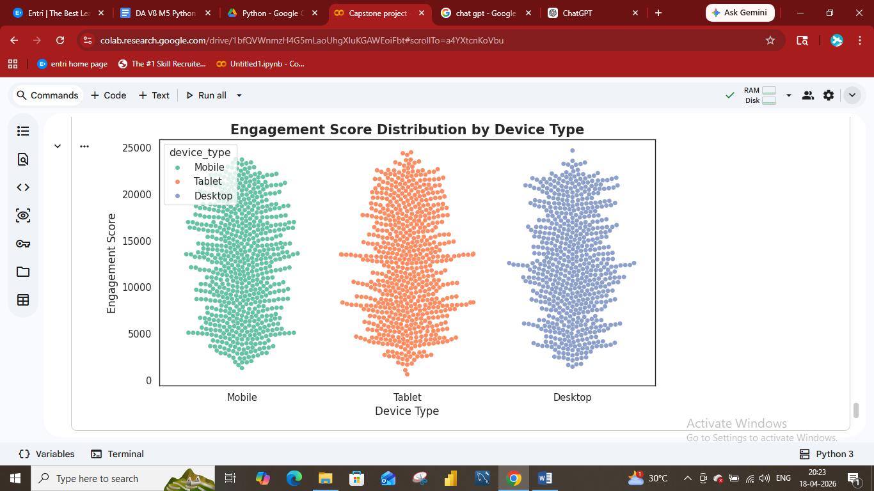
- Plotly – Interactive daily Engagement trend

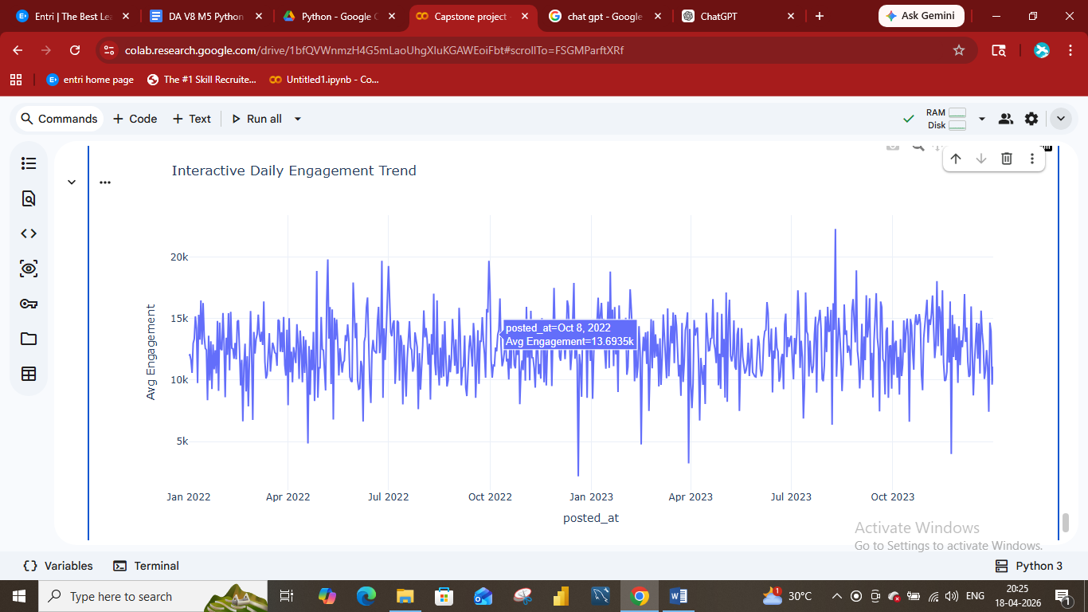

Final Conclusion
- Visual and emotionally appealing content drives the highest engagement
- User demographics (especially age) significantly influence interaction
- Posting time and platform behaviour affect visibility
- Positive sentiment boosts like and shares, while negative sentiment drives discussion
- Engagement patterns vary across regions and user types.

